Humanities and Social Sciences
(HASS)
Overview

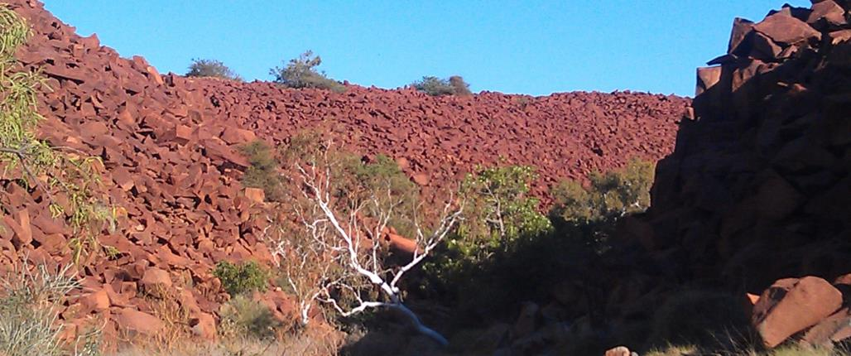
g
Geography
A road trip around Australia
In this unit, students have the opportunity to review and develop their mapping and research skills as they research and plan a road trip around Western Australia. Students participate in a range of activities to review their prior learning and to scaffold new learning in the area of Geography. Using a variety of sources students will: research, select and mark on a route map towns and/or cities and geographical, cultural and historical landmarks to visit on their journey; choose an appropriate date of travel; research the weather for their chosen destinations; create an itinerary; and, consider what they will need to pack for their journey. Through extension tasks there is the potential for cross-curricular links to History, English and Science.
HASS, Year 3  Geography: A road trip around WA |  |  |  |  | Notional hours: 12 hrs
Curriculum | Learning activities | Assessment |  | Resources
This content is applicable to the unit of work as a whole.  Knowledge and Understanding  Places are both similar and different  The location of Australian states, territories, capital cities and major regional centres of Western Australia and the location and identifying attributes of Australia's major natural features (e.g. rivers, deserts, rainforests, the Great Dividing Range, the Great Barrier Reef)  Language groups of Australia's Aboriginal and Torres Strait Islander Peoples divides their Country/Place and differs from the surveyed boundaries of Australian states and territories  The difference between climate and weather, the main climatic zones of the world (e.g. equatorial, tropical, arid, temperate) and the similarities and differences between the climates of different places  Questioning and researching  Identify current understanding of a topic (e.g. brainstorm, KWL chart)  Develop a range of focus questions to investigate.  Locate and collect information from a variety of sources (e.g. photographs, maps, books, interviews, internet)  Record selected information and/or data (e.g. use graphic organisers, develop note-taking strategies)  Interpret information and/or data collected (e.g. sequence events in chronological order, identify patterns and trends, make connections between old and new information)  Translate collected information and/or data into different formats (e.g. create a timeline, change data in to a table and/or graph)  Draw conclusions and give explanations, based on the information and/or data displayed in texts, tables, graphs and maps (e.g. show similarities and differences)  Present findings and conclusions in a range of communication forms (e.g. written, oral, visual, digital, tabular, graphic), appropriate to audience and purpose, using relevant terms  General Capabilities  Literacy  Numeracy  Critical and creative thinking  Intercultural understanding  Information and communication technology (ICT) capability | Students are going assist their family/teacher etc. to plan for a road trip around WA. This will involve a number of activities to review prior learning and to scaffold the task.  Lesson One (1 hour)  Prior to the lessons, find maps using Internet keyword search: Australia map, language, social and nation groups of Australia, Australian Aboriginal map.  To link to prior learning related to mapping:  As a class, students brainstorm everything they know about maps.  Suggested prompts: What do we use maps for? What sorts of things would you expect to find on a map? Where do you look for maps? What is a legend? What would you expect to find on a map of Australia e.g. the states and territories, capital cities, major geographical landmarks such as deserts etc.  Show students an enlarged or projected map of Australia. Ask a number of open-ended questions to gauge student knowledge. What do the straight lines on the maps mean? What are the names and locations of the states/territories? Where is Western Australia? What is a capital city? What is the name of Australia’s/WA’s capital city? etc.  Show students an enlarged, or projection, of the alternate map of Australia. Ask students, how this map differs from the last one.  Explain that the divisions on maps are man-made and on this second map represent the language, social and nation groups of Aboriginal Australians.  Lesson Two (2 hours)  Suggested introduction:  Ask students if they have travelled with their own family anywhere outside their community. Discuss and share.  Consider the Are We There Yet? Problem that occurs on long journeys. Ask students for activities they may have done on the way to help pass the time.  Distribute task sheet and introduce students to the task. Students are going to assist their family/teacher etc. to plan for a road trip around WA.  Conduct a think-pair-share of cities, towns and landmarks in Western Australia the students have visited, would like to visit or have heard about. Compile a class list to help students choose places to include on their road-trip.  Ask students to utilise atlases, travel guides, websites, mapping tools etc. to select five cities or towns across Western Australia and add them to their Road trip note-making sheet.  Find various internet based mapping tools to assist with this part of the task.  Lesson Three (1.5 hours)  Ask students what a landmark is. If necessary explain that a landmark is: a structure or object that is easy to see and recognise and/or a structure or place that has great historical, cultural or aesthetic, visual or architectural, importance.  Ask students to list landmarks in their community or area or anywhere in WA. Provide prompt examples if necessary.  Have students research any interesting geographical or cultural landmarks they might stop and during their road trip. They should use their Road trip note-making sheet and select at least two landmarks. Students may use a resource such as atlases, guidebooks and tourism websites.  Lesson Four (2 hours)  Using an enlarged or projected map demonstrate to students how to plot a route between towns i.e. draw lines along the roads of a map to represent the path to travel.  Explain that they need to consider the major roads and obstacles such as lakes, deserts and gorges while plotting their route.  Explain to students that they need to plot a route of the destinations they will visit on their road trip. This should include the five cities and or towns and at least two landmarks they will stop at. Students may use a map of WA or mapping software/app.  Distribute or access maps and allow students time to plan their travel route.  Lesson Five (1.5 hours)  As a class or individually, have students list the seasons and the months which make up the seasons (prompt if necessary).  Ask students which would be the nicest season to travel to their chosen destinations and why?  Have students select a date to start their road trip.  Explain to students that they will need to create an itinerary for their road trip. An itinerary includes the starting point, the destinations and landmarks in the order they will be visited and where the journey will be completed. It could also include the date they will arrive and the distance or travel time between each destination.  Extension  Ask students to estimate the distance or approximate travel time between each destination. This may be done with a map and ruler using the scale or using the internet. Suggested Internet Keyword Search: how far from ___ to ___  Lesson Six (1 hour)  Explain to students that in order to know what clothing and equipment to pack they need to know what the weather conditions will be like. Explain that, using the date of travel, they need to research and record the temperature and rainfall of each town and or city they have selected. Students may use atlases, guidebooks, weather websites/apps, newspapers etc.  Students will need to find the average temperature and rainfall for the month of travel for each of the destinations they have selected and record them on their Road trip note-making sheet. They should also provide a short written description of the weather for each destination e.g. hot, wet and humid or cool and dry etc.  Lesson Seven (1 hour)  Explain to students that they need to complete a list of what to pack on their chosen road trip.  Ask students to consider what they will take based on their research of the weather at each destination. Will it be hot/cold/dry/wet at each location? What sort of clothes, shoes and other equipment will they need?  Students should also consider the other activities they may engage in on the trip e.g. climbing gorges, swimming in rivers, taking photos etc.  What additional equipment will they need for these activities?  Lesson Eight (2 hours)  Students need to collate their material into an appropriate format for display. This could be a poster, scrapbook or folder or a digital alternative.  Students may like to include photos for each destination sourced from travel brochures, home, the internet etc.  Students’ completed road trip tasks could be displayed in classroom, library etc. or uploaded to a class blog.  Extension  Students find a photo of one of their chosen destinations and use it as stimulus to write a fictional journal entry imagining they are at the destination as part of their family road trip. | Formative  Brainstorming mapping terms and geographical locations and features on maps of Australia and Western Australia  Utilising graphic organisers to complete research on towns, landmarks, temperatures etc.  Summative  Route map with destinations and geographical landmarks  An itinerary with travel times and average temps/rainfall for destinations  A list of what to pack (this should reflect the research they have done for each destination) |  | Provided  Road trip note-making sheet  Task sheet and marking guide  Teacher provided  Children’s stories/books about long trips  Atlases or access to mapping software/apps, internet  Maps of Australia, with state boundaries and capital cities and alternate map with language, social and nation groups – of Australia  Map of Western Australia –with town and major road names

